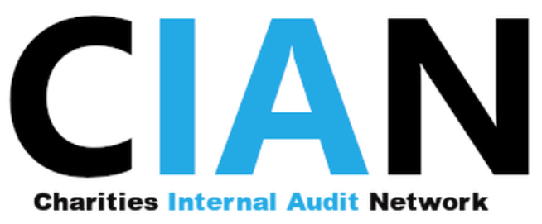

MEMBERSHIP APPLICATION FORM

Please complete the Application form below and Email to Robert Auguste, CIAN Membership Secretary at: members@cian.org.uk

Ordinary membership of CIAN shall be open to any charitable or not for profit organisation (“charity”) interested in furthering the objects of CIAN. Acceptance of membership is subject to approval of the Executive Committee and is contingent upon the satisfactory completion of a CIAN Membership Application Form with details of the organisation and key contacts.

One nominated representative of the member organisation, who is an individual employed or contracted by the ordinary member either as an internal auditor or otherwise with responsibility for internal control or risk management, may attend meetings of CIAN. All other individuals with similar responsibilities, may also attend meetings either as a substitute for, or if sufficient space is available, in addition to the nominated representative if they are confirmed to CIAN as alternative representative of the member organisation.

DATA PROTECTION STATEMENT

By submitting this application for membership, you are agreeing to any personal details listed on the attached Directory Questionnaire being stored on the Charities Internal Audit Network membership database and to the nominated representative name and email being shared with other members of the Network. CIAN do not make the membership list available to any outside organisations.

www.cian.org.uk

Charity Name:

Charity Registration No.:

Charity Registered Address:

Charity website:

Nominated Representative:

Nominated Representative Job Title:
Nominated Representative Telephone No:

Nominated Representative E-mail Address:

Name, role and email of alternative contact at charity:
(to be contacted if nominated representative no longer at charity / not contactable)
Purpose/
Objectives of Charity:

Main Activities:
(e.g. grant making, service provider, retail, education, advice & consultancy, volunteers etc.):

Total Income:

Voluntary / Fundraising Income:

Geographical Spread:

Number of Employees:

Number of charity shops:

Who at your charity /not for profit organisation is responsible Internal Audit (or for internal controls if you have no internal audit function)?

Internal audit structure (Fully in house / co-source / fully outsourced)
How many internal audit FTE are there at your organisation?
Reporting Structure/
Framework:
How does the Internal Audit function report
(eg verbal, written reports, who receives reports) and what is its line management? (eg. Finance Director, Audit Committee, etc.)
How did you hear about CIAN?

Names and Email addresses of any other Internal Audit staff who you wish to add to the CIAN mailing list.

Date form completed

I agree to the personal details listed on this application form being used by the Charities Internal Audit Network for membership purposes, and to the nominated representative name and email being presented alongside key details of the charity in the listing of members that is shared with all members of CIAN. CIAN do not make the membership list available to any outside organisations.
(Please place an ‘X’ in the box above to consent)

